**Phys 2020 Test 3 Review Questions and Problems**

This will help you prepare for the test, but the test questions will be different than these, and the material may differ slightly. Everything covered in this review may not appear on the test, and it is possible for the test to cover material that is not in this review.

-------------------------------------------------------------------------------------------------------------------------

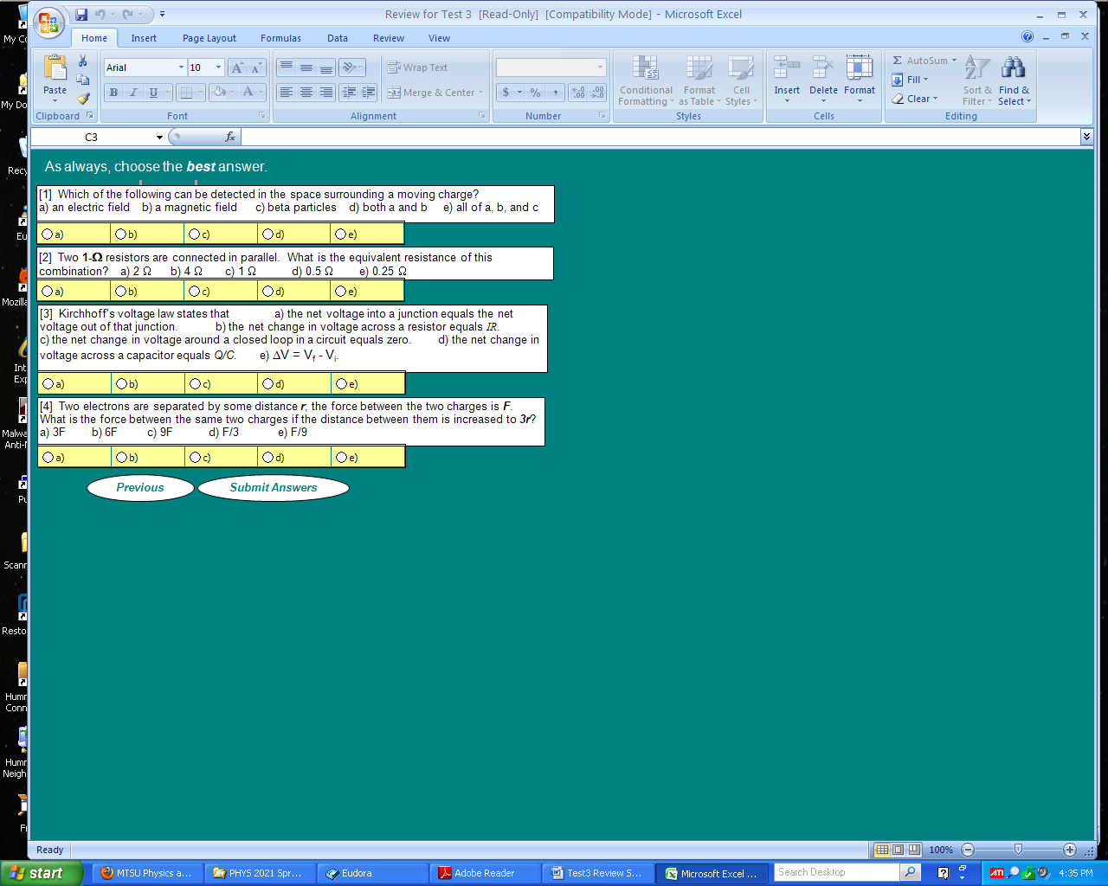

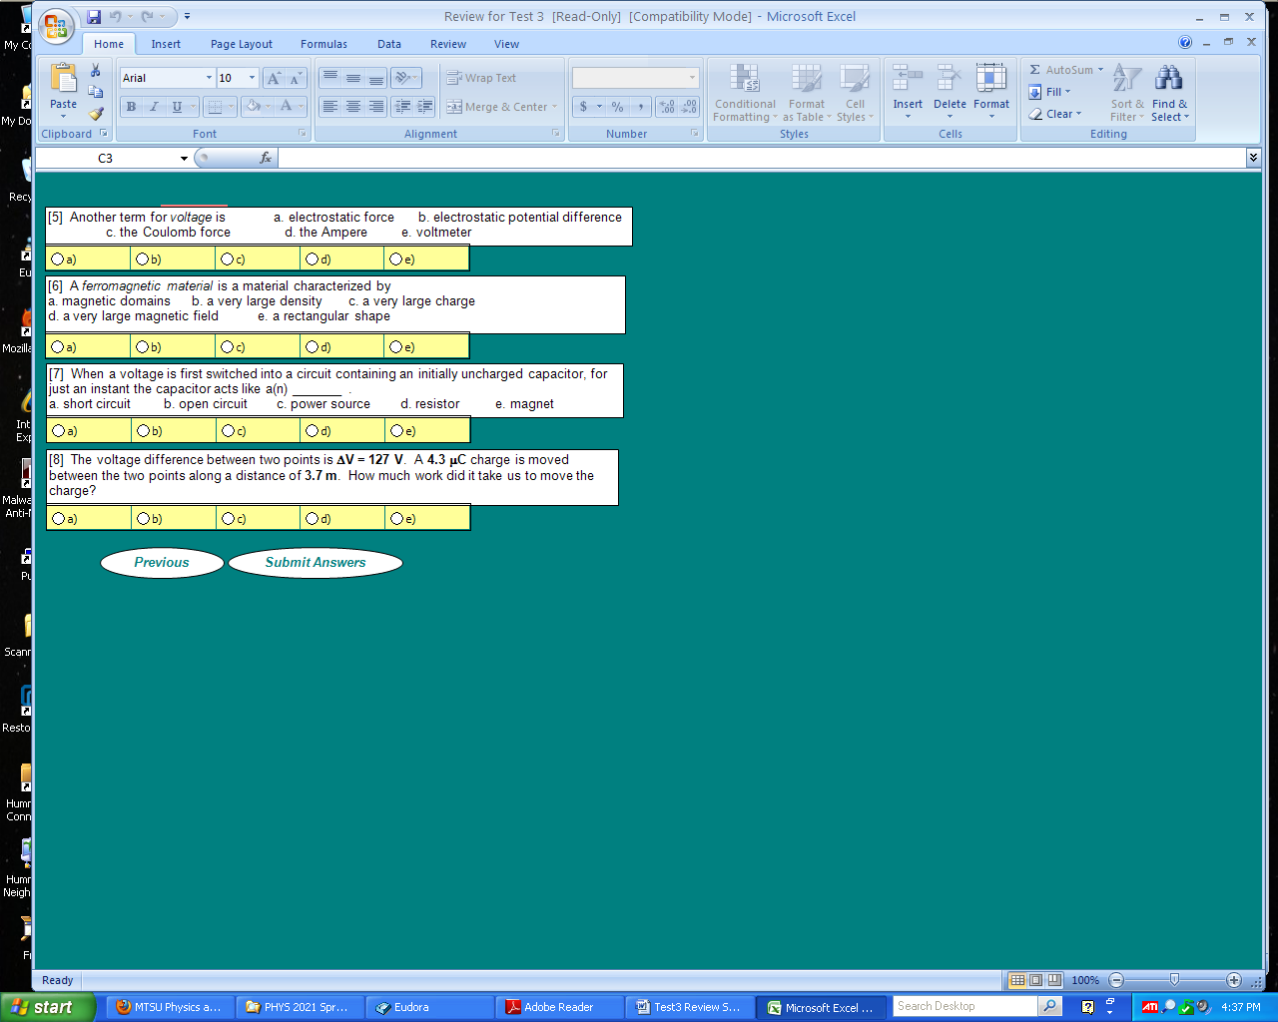

The following questions concern the oscilloscope trace shown below. The vertical sensitivity of the oscilloscope is set at **2 V / DIV**.

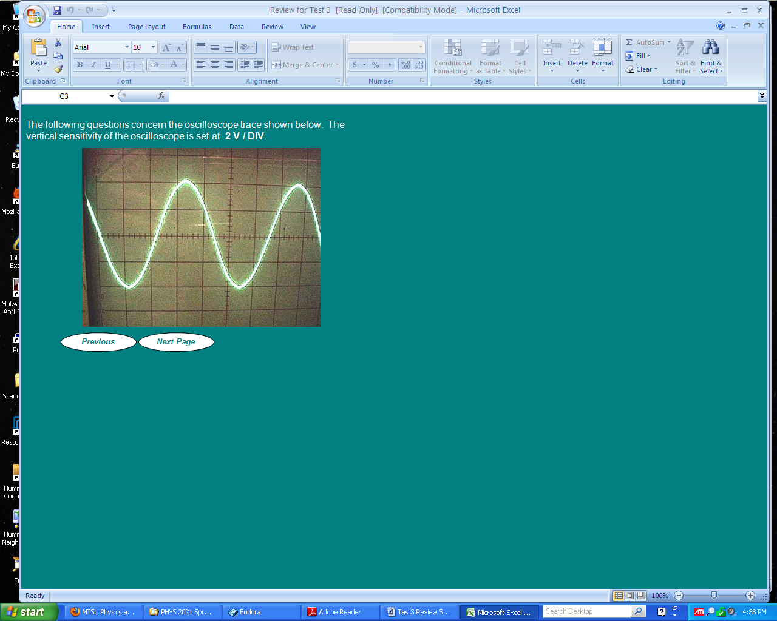

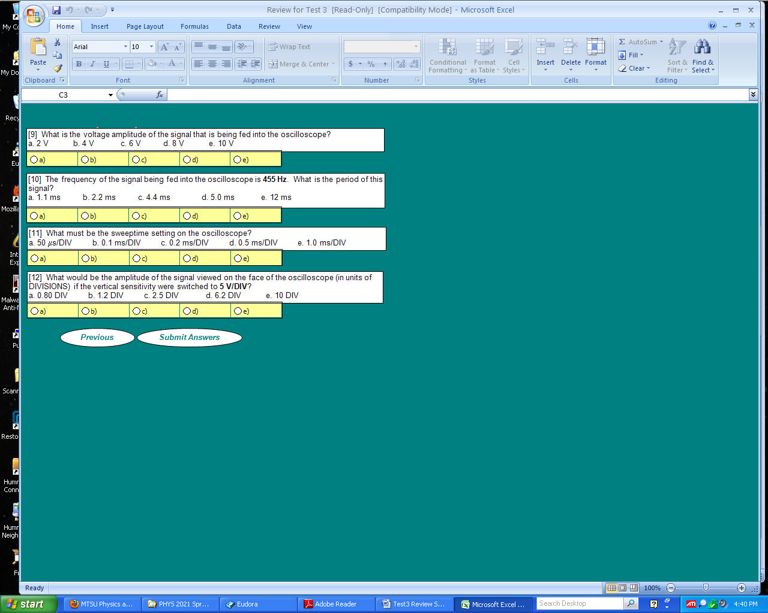

The circuit shown below contains four identical resistors, **R1 = R2 = R3 = R4 = 15 kΩ**, and a power supply of voltage **ΔVs = 35 V**. (Make a sketch of this circuit for the upcoming problems.)

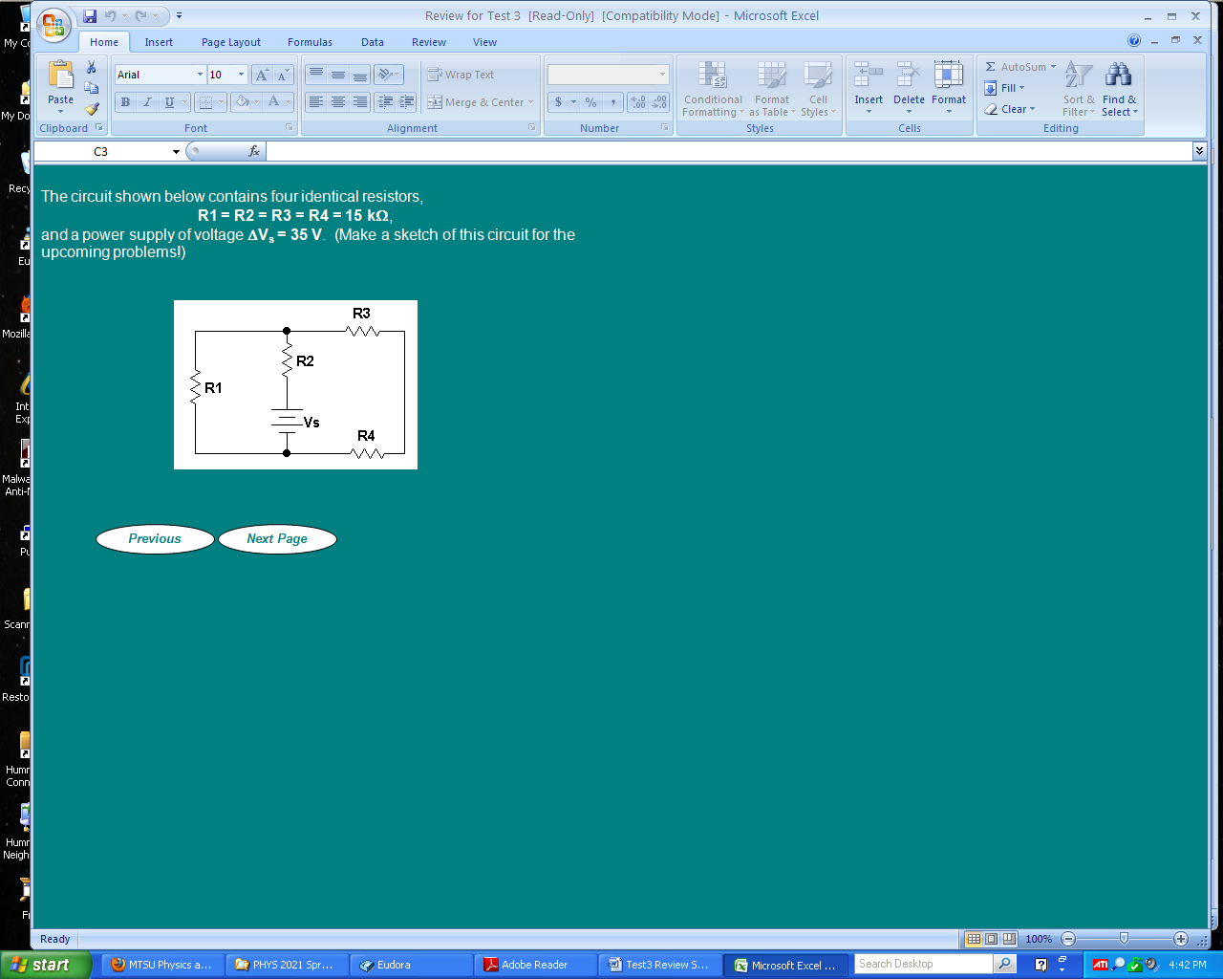

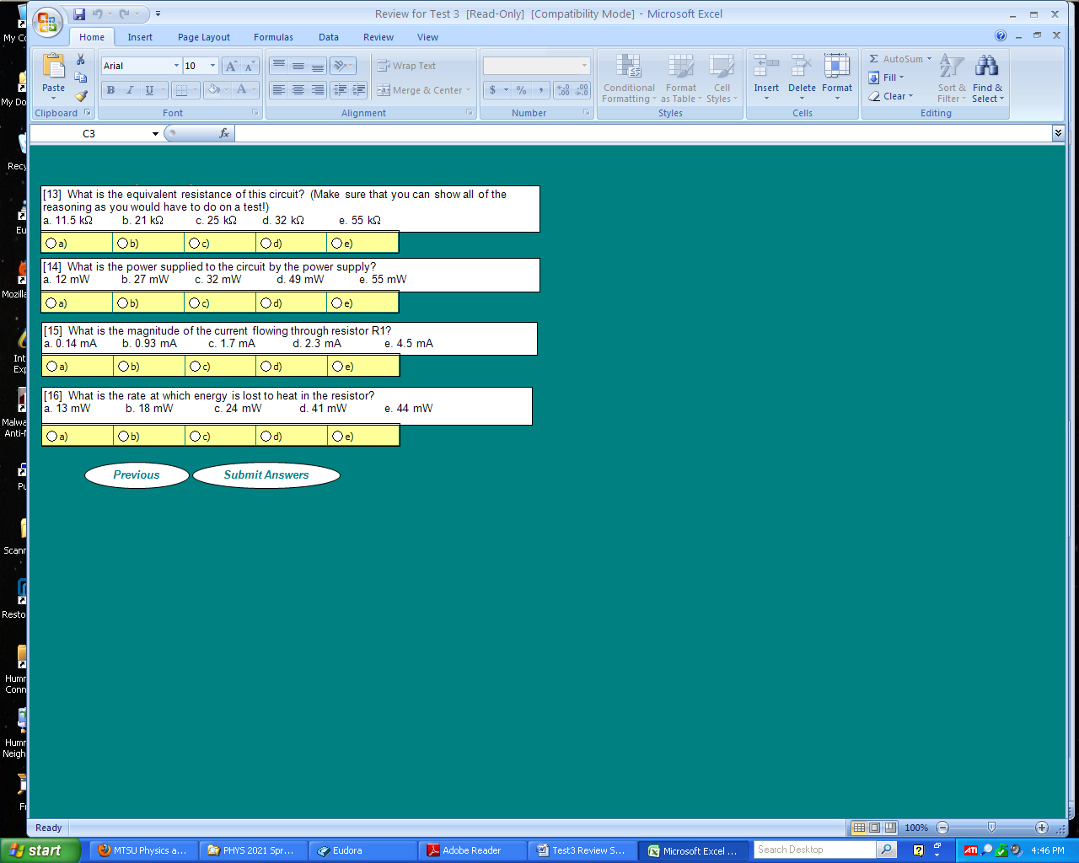

The heating of the resistor is, of course, called **Joule heating**, and is a result of electrons moving through the resistor (which is a conductor) and colliding with the atoms making up the resistor, thereby causing them to heat up. You should have seen that the current through resistor R1 moves *down* through that resistor in the circuit diagram.

A circular loop contains 250 turns of wire. The radius of the loop is a = 23 cm; it lies in a region of a uniform magnetic field of (initial) magnitude Bi = 1.8 mT, as shown in the figure. The loop has a total resistance of R = 0.17 Ω.

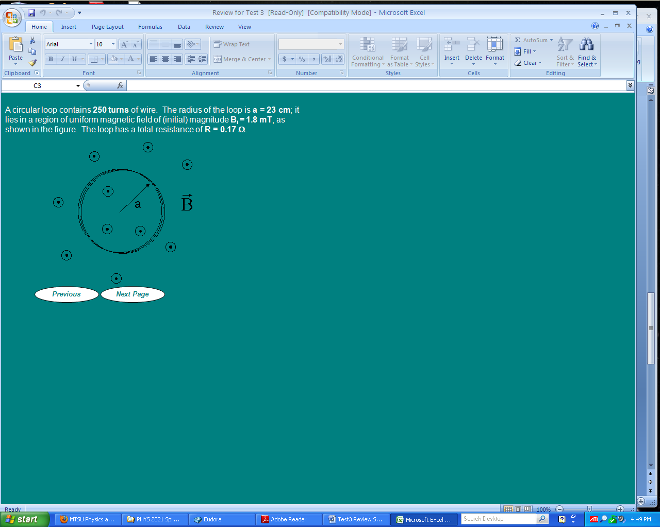

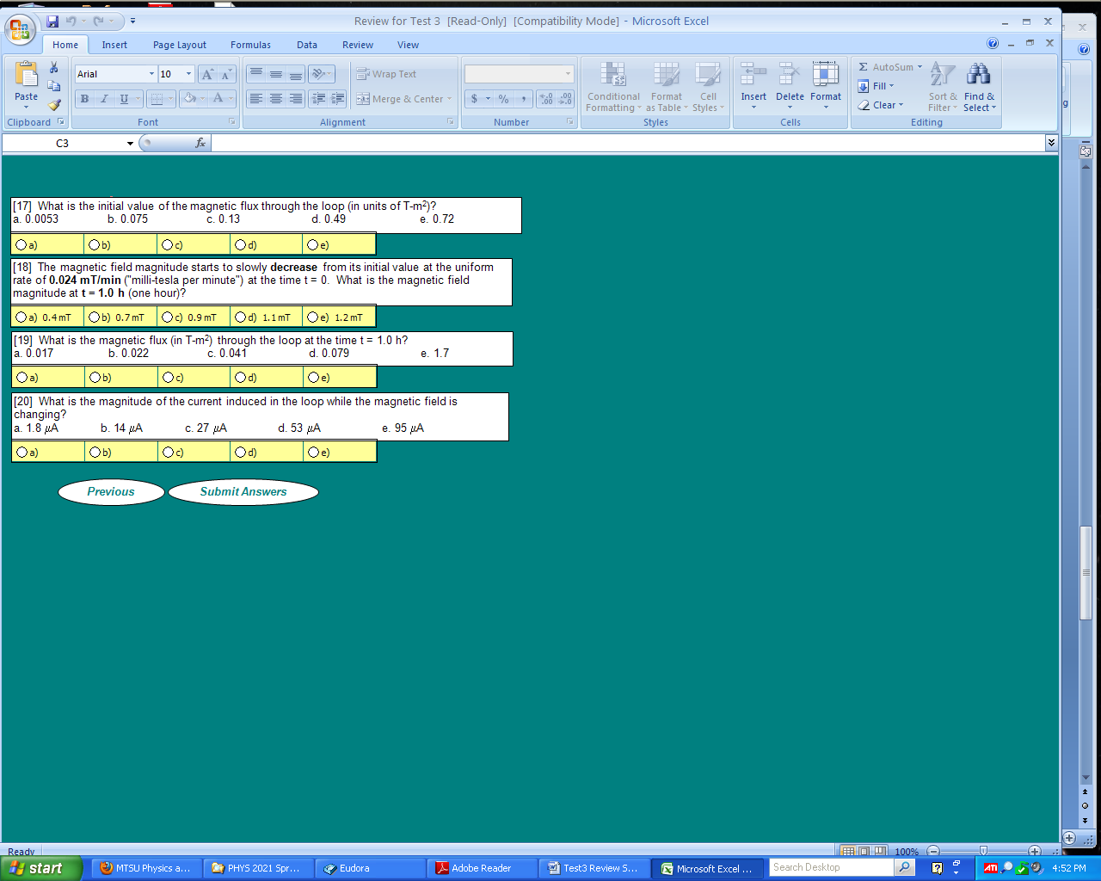

Can you reason out the direction of the current flow in the previous problem? You should be able to deduce that the induced current must flow in the **counterclockwise** direction around the loop as the magnetic field magnitude is decreasing. Remember that the current flows in such a direction that the magnetic field it induces will **oppose** the **change** in magnetic flux!

The TTL signal shown below is fed into a series RC circuit with R = 400 Ω and C = 1.1 μF. The oscilloscope is set on 1 V / DIV and 0.2 ms / DIV. The TTL signal of course acts like a switch across the RC circuit, alternately placing a ground signal or a constant voltage ΔVmax across the series combination of the resistor and capacitor.

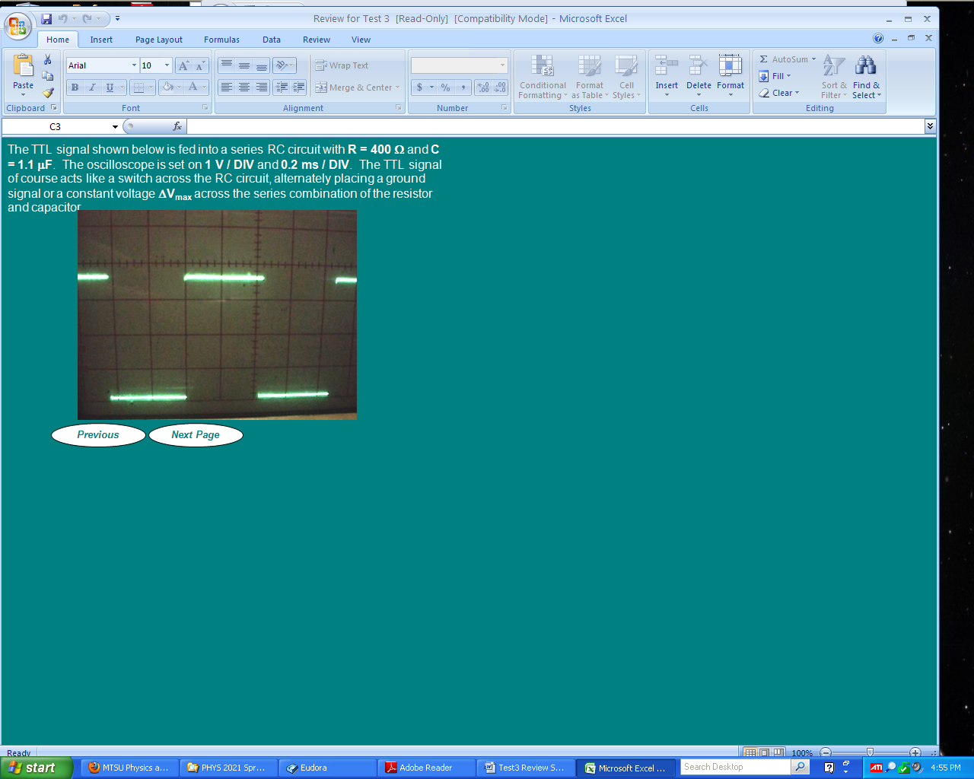

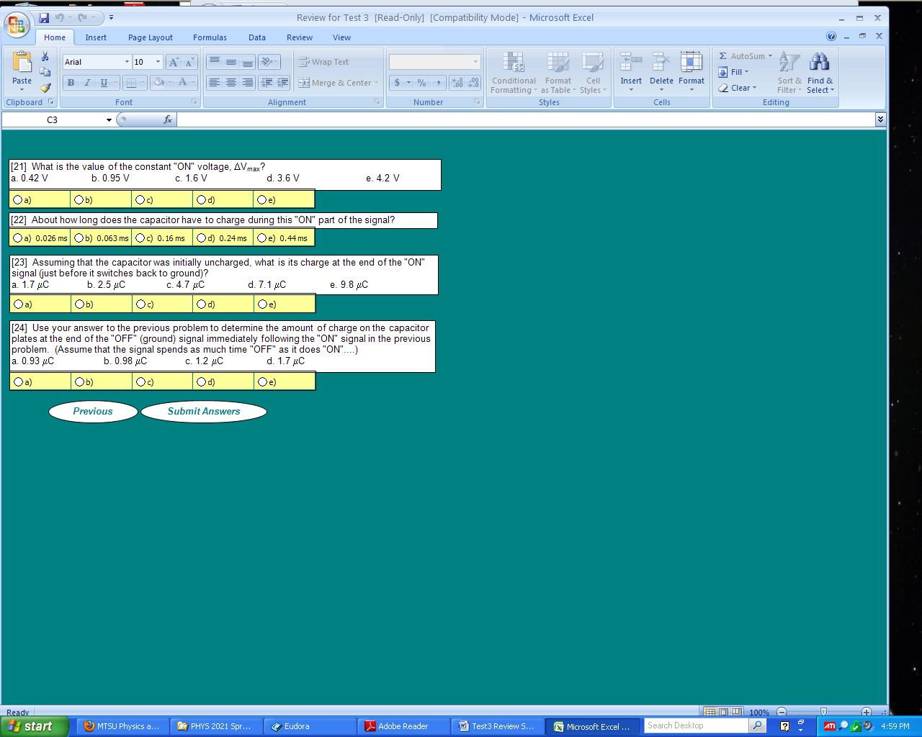

**Phys 2020 Test 3 Review Answers**

|  |  |  |  |
| --- | --- | --- | --- |
| 1. d | 2. d | 3. c | 4. e |
| 5. b | 6. a | 7. a | 8. c |
| 9. b | 10. b | 11. d | 12. a |
| 13. c | 14. d | 15. b | 16. a |
| 17. b | 18. a | 19. a | 20. e |
| 21. d | 22. e | 23. b | 24. a |